Excellent! Surplex wins HR Excellence Award 2020
It's official since last Friday: Surplex GmbH's internal training series "Learning at twelve o'clock" (in German "Zwölfuhrschlau") has been awarded the HR Excellence Award 2020! At this year's awards the concept could not be beaten in the category "SMEs Learning & Development (Learning Culture)". Surplex GmbH and three other companies made it onto the shortlist in this category at the beginning of November. Last Friday, Karin Schneider (Senior HR Generalist) and Katja Sankowski (Head of HR) beat the competition in a live online pitch.
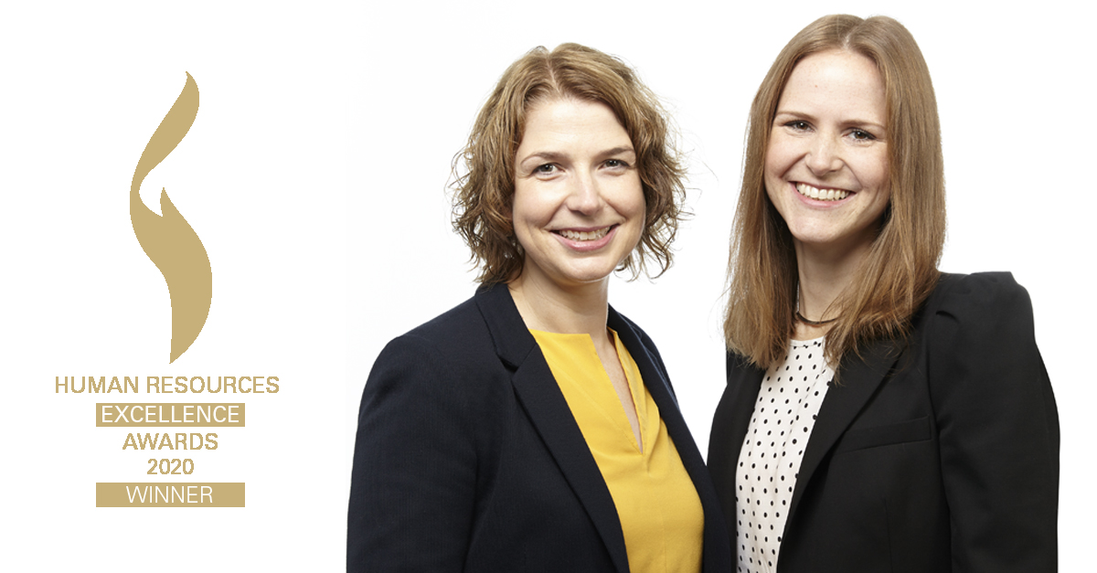
The HR Excellence Awards (HREA) annually reward the best achievements in human resources. The most innovative and creative ideas are nominated here. Concepts that set new standards in future HR work and are honoured in the form of the award.
"We are happy that the new format "Learning at twelve o'clock" has not only met with enthusiasm internally at Surplex, but also impressed the jury of the HR Excellence Award. The commitment of the HR department, but above all the dedication of our employees was rewarded. This makes us proud", explains Ulrich Stalter, managing director of Surplex GmbH.
"Smart aleck was yesterday, today is learning at twelve o'clock”
– is the slogan of the internal training series by and for the Surplex team. All lecturers, who share their knowledge - whether professional or private - with interested colleagues, work at Surplex themselves. True to the company's mission statement: "We are colourful", very different, approx. 60-minute learning appetizers are created, which are taught during the lunch break, at lunch or over a cup of coffee. The series started on site, but due to the Corona pandemic it has since been continued via Microsoft Teams. Participation is voluntary and all team members - regardless of position and activity - can listen or present a topic themselves. There is also the possibility to view many of the past "Learning at twelve o'clock" as a recording in the company's internal wiki.
The "Learning at twelve o'clock" range of topics extends from Excel and Trello training courses to handlettering courses and mini-Japanese courses. A positive side-effect: Within the "Learning at twelve o'clock" seminars, colleagues from the most diverse specialist areas meet each other, so that new acquaintances are made beyond the boundaries of one's own department.
The format is to be continued in 2021, then in English and for all international locations.

About Surplex:
Surplex is one of Europe's leading industrial auctions and trades worldwide with used machinery and equipment. The 16-language auction platform surplex.com records approximately 50 million-page views annually. More than 55,000 industrial goods are sold each year at more than 500 online auctions. The company based in Duesseldorf (Germany) has offices in eleven European countries. More than 200 employees from 20 nations generate an annual turnover of approx. EUR 100 million.

Your press contact:
Dennis Kottmann
Head of Marketing
www.surplex.com
Tel.: +49-211-422737-28
Fax: +49-211-422737-17
Email: dennis.kottmann@surplex.com

