Used machinery trade in times of corona
Help in case of insolvency or restructuring
Especially in times of corona, used machines are a valuable liquidity reserve. Worldwide machine auctions are booming. How Surplex helps the industry through the crisis.
Many industries are suffering from declining sales due to the pandemic. The second corona wave is rolling, and there is no end in sight. The only thing that is clear is that all industries are under great pressure to change. A market shakeout is to be expected in some cases and a wave of modernisation in others. Some companies are threatened with insolvency, others are investing in new plants and machinery or specialising. But both processes - insolvency or restructuring - will release large quantities of used assets. Either to service creditors' claims or to create liquidity for the acquisition of new equipment. The question “where to put the decommissioned machinery?” is likely to become increasingly urgent for the entire industry. Especially in times of crisis, it is therefore worth considering how best to sell used fixed assets in order to keep the costs of insolvency or modernisation as low as possible.
Online industrial auctions: the new standard in global machine trade
The used machinery market, whose global volume is estimated at around 380 billion euros, has itself undergone a crisis of adjustment in the wake of digitisation. Some players have had to give up. Others, such as the industrial auction house » Surplex, have grown from 16 to 200 employees in a few years and now have branches in 13 European countries. The major players have ensured that the still young sales format of online industrial auctions has become the industry standard. Whereas in the past sales were dependent on non-transparent and regionally limited trading structures, today this instrument can be used to auction off surplus machinery at the best price on the world market. A revolution in the machine trade. And a great opportunity for all those who want or have to sell used machines in times of corona.
The formula for success: digital know-how plus comprehensive service
But the greater the opportunity, the greater the challenge. Hardly any other service is as complex as modern industrial utilisation. It is not enough to sell machines worldwide. Rather, these sales must first be comprehensively prepared and then professionally handled. That is why sales success stands and falls with the question of whether the commissioned service provider meets certain quality criteria.
Firstly, a powerful auction platform must be in place. On surplex.com, for example, more than 500 online auctions are held annually, with more than 55,000 machines and factory equipment changing hands. The platform is available in 16 languages and records over 50 million views per year.
Secondly, professional online marketing must be done, because it is easy to present machines on a web platform, but difficult to generate the reach and visibility necessary for the global market.
Thirdly, professional market and industry knowledge is required to evaluate machines in line with the market and to advise the seller at an equal level. That is why Surplex has had a clear focus on metal and woodworking for 20 years and employs countless experts who are well versed in these machines.
Fourthly, it is important to dovetail online and offline expertise, because the global used machinery trade thrives on pre- and after-sales service. This is where Surplex has a unique selling point, because the Düsseldorf-based company is the only industrial auction house in the whole of Europe that offers all services from a single source, including dismantling, loading and customs clearance.
Fifthly, the service provider should offer flexible selling options, including, for example, the direct purchase of all assets for short-term payment, in order to create immediate liquidity for the Principal.
With Surplex strengthened through the crisis
Online industrial auctions are the best way to sell used machinery in the most profitable way. Whoever exploits the worldwide market potential achieves the highest revenues. However, this only applies on condition that the commissioned service provider meets certain standards. It is therefore worth separating the wheat from the chaff. Unfortunately, many sellers do not inform themselves sufficiently about quality differences in industrial utilisation and are content with sub-optimal results. But if you want to emerge stronger from the coronavirus crisis, you need a strong partner at your side.

About Surplex:
Surplex is one of Europe's leading industrial auctions and trades worldwide with used machinery and equipment. The 16-language auction platform surplex.com records approximately 50 million-page views annually. More than 55,000 industrial goods are sold each year at more than 500 online auctions. The company based in Duesseldorf (Germany) has offices in eleven European countries. More than 200 employees from 20 nations generate an annual turnover of approx. EUR 100 million.
Picture:

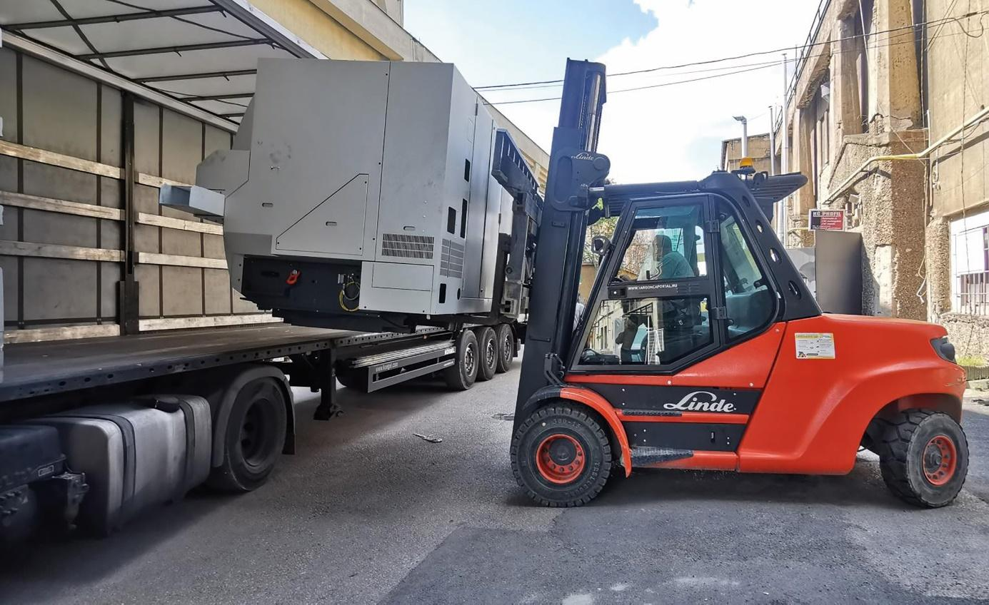
Machine loading after online industrial auction (Picture: © Surplex)

Related contact person:
Dennis Kottmann
Head of Marketing
www.surplex.com/en
Tel. : +49-211-422737-28
Fax : +49-211-422737-17
Email: dennis.kottmann@surplex.com

